**StorifyX App**

**Aim:**

To design an interactive storytelling app that allows users to select, personalize, and experience stories with customizable narrators and user-friendly navigation.

**Procedure:**

* **STEP 1:** Create a new project and set up frames for each screen, including Welcome, Sign Up, Sign In, Story Selection, Story Details, Profile, Settings, and Customization screens.
* **STEP 2:** Set background colors, grids, and guides for consistent layout and alignment across screens.
* **STEP 3:** Add text, images, buttons, icons, and form fields on each screen, focusing on a visually engaging interface.
* **STEP 4:** Design interactive states for buttons, form fields, and selection options to make the app feel responsive and engaging.
* **STEP 5:** Link frames to enable smooth navigation between screens, allowing users to move through onboarding, story selection, customization, and playback. Preview the prototype to test and refine the flow.

**Diagram:**

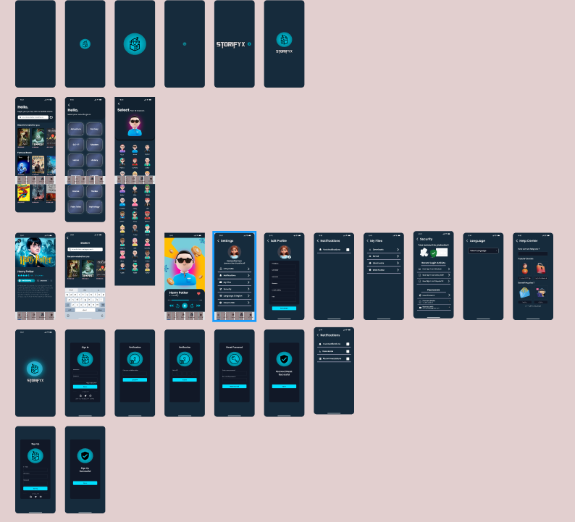

**Result:**

A visually appealing and intuitive mobile app prototype that lets users explore and personalize storytelling experiences. This design emphasizes ease of use, engagement, and customization, providing users with a unique and immersive way to interact with stories.